A whole provider approach to widening access and student success in higher education: Toolkit and guidance

Liz Thomas, Centre for Research on Education and Social Justice, University of York
liz.thomas@york.ac.uk

Introduction
This toolkit and guidance focus on conceptualising, analysing and using a whole provider approach (WPA) to promote equity in higher education. We acknowledge that terminology varies between contexts and evolves over time. We have opted to use the term 'widening access and student success' to cover issues relating to student diversity, equality and inclusion across the student lifecycle (access, continuation, completion, attainment and progression beyond HE). We use the term ‘equity’ to refer to equality of outcomes, as we recognise that individuals and groups do not experience a level playing field prior to potentially entering higher education.
In England, the Office for Students (OfS) which regulates the HE sector requires higher education providers (HEPs) that charge higher level fees to prepare an Access and Participation Plan (APP). In the current iteration, HEPs are required to set out how they are taking a ‘whole provider approach’ to address the risks to equality of opportunity (OfS 2023a). A whole provider approach is also of interest to those not required to submit an APP (see for example ‘whole-of-institution’ work in Australia, Kift 2015, 2023).

What is a whole provider approach?
In summary, a whole provider approach focuses on widening access and student success interventions operating across the whole institution, contributing to consistency and equity for all students throughout the student lifecycle. Working across the HEP involves institutional alignment (Felten et al 2015), ensuring that policies, processes, practices and resources match institutional commitments and student characteristics, by working across ‘traditional organisational boundaries’ (Kuh et al 2010, cited in Felten et al 2016, p92). It also requires staff from departments, services and units from across the institution being involved in widening access and student success (not just ‘professional widening participation’ staff (Thomas 2017)) and ideally for staff and students to work in partnership (OfS 2023b).
The model presented here in figure 1 draws on previous research (Jones and Thomas 2005, Thomas 2002, 2017, 2018a, 2018b, Thomas & Tight 2011, Thomas et al 2017), analysis of wave 1 Access and Participation Plans (APPs), and work with 28 higher education providers from across the English higher education sector. A whole provider approach involves an inclusive student experience (widening access and student success), and an enabling environment to ensure equity for all students.

Figure 1: Whole provider approach
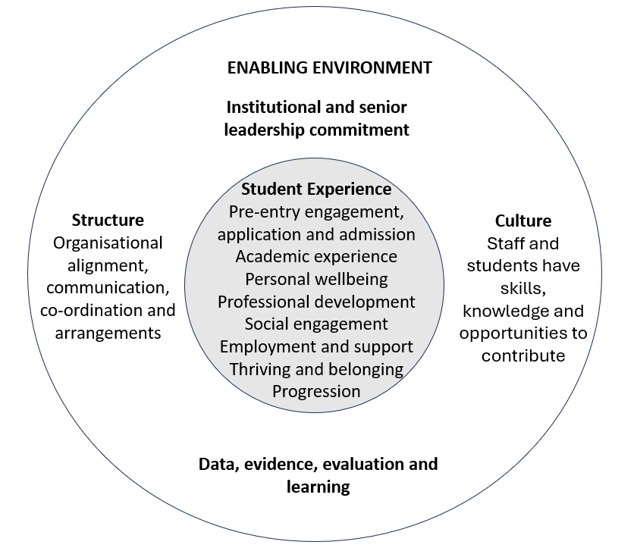

Student experience
A whole provider student experience indicates that interventions (practices, services and opportunities) are available to students across the HEP, rather than just in particular sites, departments or courses. Building on other research it is argued that a whole provider approach should be based on institutional change rather than requiring students to adapt and fit in (Kift 2015 & 2023, Thomas 2002, Thomas & Tight 2011, Zepke & Leach 2005). Furthermore, research has demonstrated that the most effective way of reaching students – particularly those targeted by widening access and student success interventions - is through the curriculum (Kift 2024, Thomas 2012) rather than through supplementary activities, as participating in learning is often prioritised above the wider student experience (Thomas 2020). It is however acknowledged that sometimes a targeted and proactive approach is required to meet the needs of specific groups (Moore et al 2013).
When designing an evidence-informed approach to equity – for example when preparing an APP following an analysis of performance and assessment of risks (Ofs 2023a, 2023b) – a range of interventions may be utilised (see figure 2):
- Pilots of new interventions and activities (these may be designed for specific groups of students or all students).
- Interventions that are rolled out across the whole HEP, (potentially) benefitting all students.
- Targeted interventions aimed at specific groups of students who do not benefit from universal interventions or who experience a particular inequality.
- Business as usual (BAU), referring to core HEP activities, services and approaches into which equity considerations have been integrated and become the usual way of doing things.

Figure 2: Types of student experience interventions
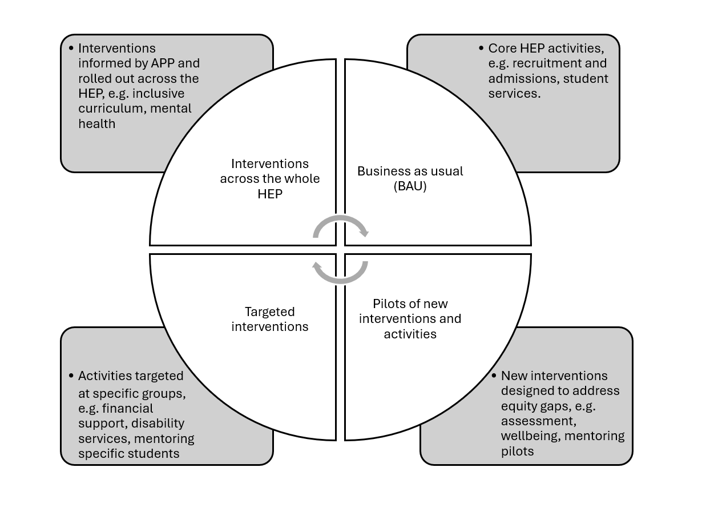

The aspirational goal of a WPA approach is to build all (or at least the majority of) widening access and student success interventions into the core functions of the HEP, so that achieving equity is part of a HEP’s normal ‘business as usual’ approach. A HEP that achieves this could be thought of as a mature organisation in relation to widening access and student success, as demonstrated in figure 3.

Figure 3: Widening access and student success maturity model
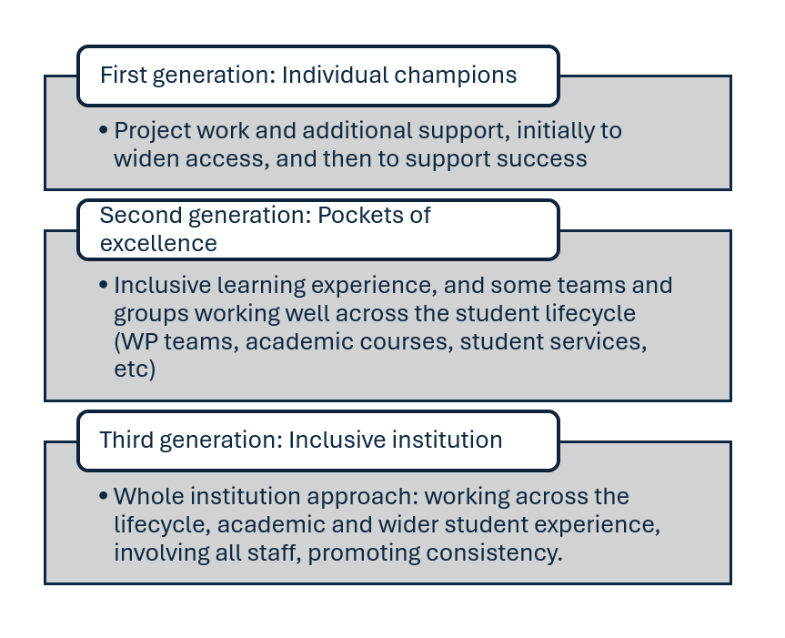

Enabling environment
Student experience interventions, HEPs and indeed the whole higher education sector mature over time. Past experience (notably the What works? Student retention and success change programme, Thomas et al 2017), identified institutional level challenges that impede embedding equity into the student experience within a HEP. The process of maturing – moving towards inclusive policies, processes, practices and ways of doing things that facilitate and promote equity – is facilitated by an enabling environment. Thus, a whole provider approach not only refers to student experience interventions across the whole institution, but also to the existence of an ‘enabling environment’ to facilitate institutional transformation. Figure 4 demonstrates the relationship between different types of student experience interventions over time and indicates the role of the enabling environment. Interventions frequently begin as pilots (e.g. design to address a specific gap or risk); these will be evaluated, and the learning will be used to enhance the intervention. Once it has been improved and its effectiveness has been demonstrated it should be rolled out across the whole of the HEP. Some interventions will be embedded in the curriculum and reach all students, while others may be targeted at specific groups of students who have not benefited from inclusive interventions. These interventions should (aim to) become part of every day practices of the HEP, or ‘Business As Usual’ across all parts of the HEP. BAU work that aims to widen access and improve student success should be monitored and evaluated to ensure that specific target groups do benefit equally or more than more advantaged groups.
The enabling environment consists of four dimensions. (1) Institutional and senior leadership and commitment to diversity and success, which is explicit, clearly communicated and demonstrated. (2) Structural issues including the alignment of institutional policies and processes to support widening access and student success and organisational arrangements that communicate, co-ordinate and facilitate widening access and student success work across the HEP. (3) Cultural issues refer to the beliefs, values and norms or practices of the HEP, and includes students as well as staff. Staff and students should understand the institutional commitment to widening access and student success, and have the relevant skills, knowledge and opportunities to engage with the agenda and work together collaboratively. (4) Widening access and student success work is underpinned by data, evidence, evaluation and learning.

Figure 4: Relationship between different types of student experience interventions and the role of the enabling environment
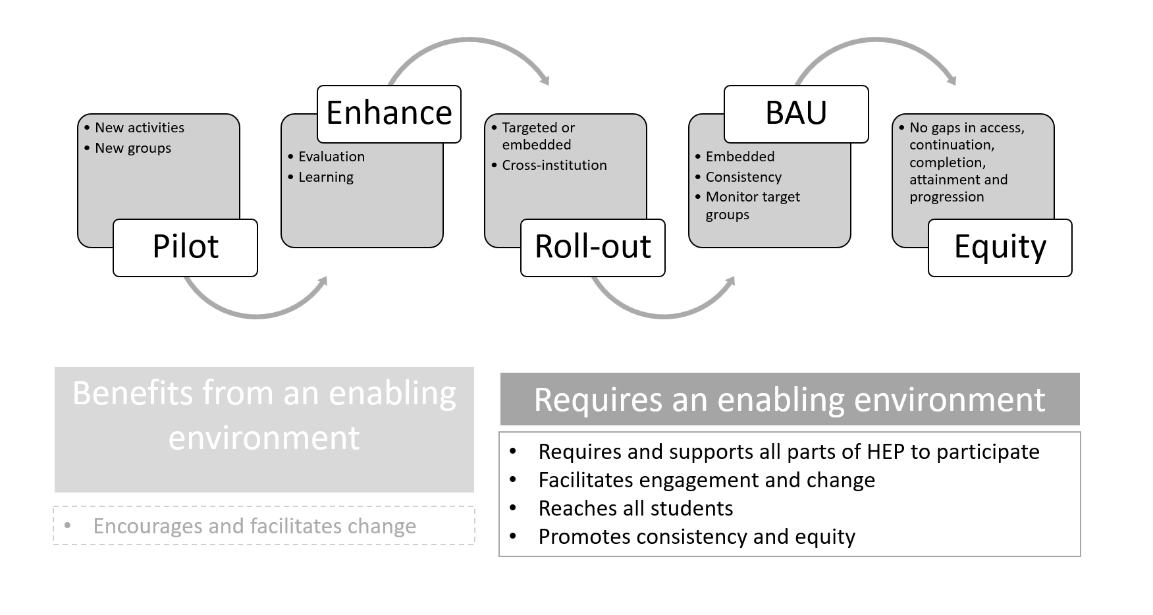

About the WPA tools
As part of our work to support English HEPs preparing their APPs, we developed a toolkit. Participants in our WPA programme of support were introduced to the tools and encouraged to use them and provide feedback. Our tools are:
- Self-assessment of WPA. (a) Initial reflective questions; (b) More in-depth reflection.
- Student experience mapping tool.
- Enabling environment review tool.
- WPA template (for writing this section of the APP).
- WPA impact evaluation theory of change template.
- WPA evaluation framework (in development).
The toolkit can be downloaded here.
Feedback from colleagues who participated in the WPA support programme suggested that reviewing the whole provider approach is useful starting point when developing an APP or other strategic work to widening access and student success. It provides an opportunity to share different perspectives and develops appreciation of alternative experiences, and either identifies issues for further exploration, or areas of strength and underdeveloped aspects of the HEP’s approach.
The tools are designed to encourage reflection through discussion and dialogue; there no right or wrong answers. Ideally, the tools will be used collaboratively, although it may be more feasible for reflection to be undertaken independently or in small groups with a discussion to be facilitated afterwards. Most of the tools allow individuals to input their views asynchronously, or can be adapted to enable this.
While we believe that staff and students from across the HEP should be involved in the process of reviewing the WPA, we recognise that people may not have worked together previously, and we acknowledge the different levels of confidence and comfort that participants may experience in sharing candid views and experiences. People’s positions within an HEP may mean that they feel more or less empowered to engage in this process; students or junior members of staff could feel vulnerable. It may therefore be valuable to organise team building activities to develop trust before critiquing your HEPs WPA or if you are short of time, you may prefer to set some ground rules to inform the discussions. In short, whoever is leading the review process should be mindful of these power dynamics and seek to create a safe space for sharing, with ground rules, trust building and the inclusion of mechanisms to facilitate anonymous sharing.

Reviewing your whole provider approach
The first of our tools (tools 1-3) are designed to develop understanding of WPA and assist HEPs to review their whole provider approach.

Tool1a and 1b: Self-assessment of WPA
These two tools were developed as part of the original study examining a whole institutional approach to widening participation (Thomas 2017). They are reproduced here and can be downloaded here.

(a) Initial reflective questions
The aim is to use these reflective questions to help surface different perspectives and develop a shared understanding. Tool 1a is intended to be quicker and can be used provide some more immediate insights into your WPA.
- Is attention to and support for widening access and student success embedded across the student lifecycle: access, continuation, completion, attainment and progression?
- Is consideration given to equity in the wider student experience?
- Is widening access and student success an institutional priority, with clear target groups identified, and reflected in all policies, processes and leadership at all levels?
- Is everyone involved in widening access and student success, sharing ownership of the agenda and being allocated resources?
- Are there opportunities for staff and students to learn from each other and experts, and to have their contribution to widening access and student success recognised?
- Are data and evidence used to inform strategic planning, everyday practices and monitoring of students’ engagement and outcomes?
- Is widening access and student success activity co-ordinated to avoid fragmentation, duplication and gaps, and to create consistent student outcomes?
There is no prescribed way to use this tool, but it could be a discussion piece at planning meet or at the start of a WPA workshop. Alternatively you could invite people to respond to these questions anonymously using an online tool such as Padlet.

(b) More in-depth reflection
The second tool provides the opportunity for more in-depth reflection on your whole provider approach. In the original report it is suggested that this tool could be used within a workshop, exploring each item in the context of your HEP.

Figure 5: WPA self-assessment tool 1b
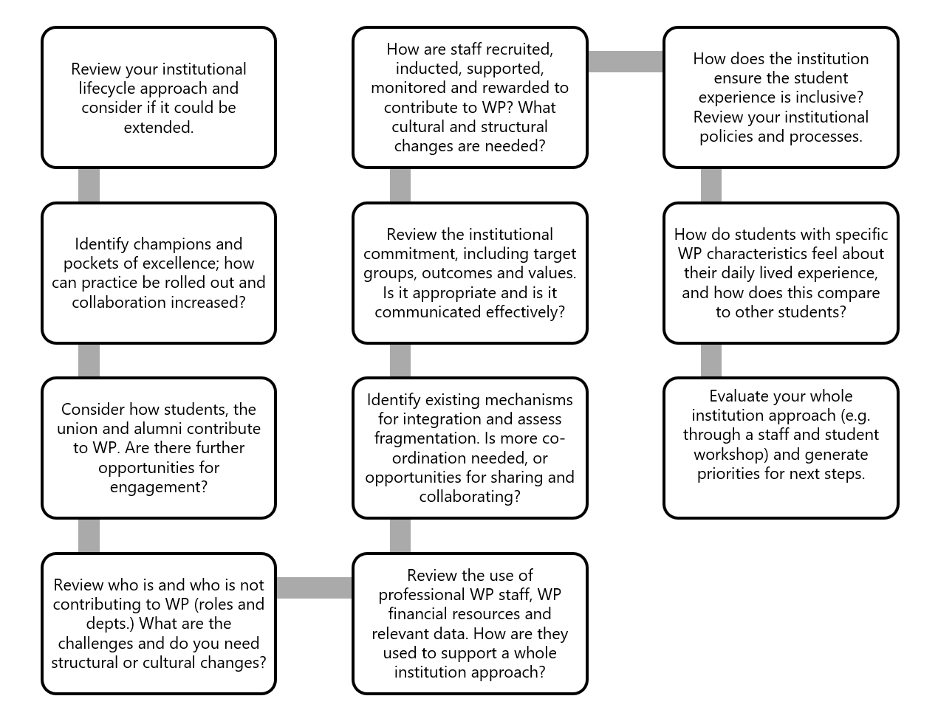

Tool 2: Student experience mapping tool
This tool is useful for collecting information from across the HEP about all the work contributing to widening access and student success. It is divided into three key categories: access, success and progression to graduate employment or a higher level of study. Within these, it is divided into further sub-categories. This will be particularly useful if you have a lot of activity across a large HEP; for smaller HEPs it will allow you to think about any additional interventions that might be useful. The tool can be downloaded here.
Mapping your student experience activities will allow you to:
- Consider whether you have a strategic or consistent approach across the HEP or multiple and fragmented interventions.
- To identify duplication or similar activities in different parts of the HEP.
- To detect potential gaps in your student experience activities.
Once completed and reflected upon, the mapping activity can be used to assist the process of deciding the intervention strategy to be developed to address inequalities in your widening access and student success experience and outcomes.
A key question to answer in relation to the APP is whether student experience work is identified as an ‘intervention strategy’, or part of the ‘whole provider approach’. Some interventions will clearly be designed and implemented to address risks to equality and to achieve institutional objectives, while others may have been developed and embedded as part of a previous APP, and now be part of mainstream provision. The latter may therefore be better located within the whole provider approach section. Similarly, some aspects of the student experience may be delivered as part of institutional core ‘business and usual’ - for example, recruitment, induction, inclusive learning and teaching, student wellbeing services, careers services. If these activities support the overall APP objectives, they should probably be included in the whole provider approach section. You should monitor and evaluate ‘business as usual’ activities to ensure that students from target groups benefit proportionately from these aspects of the core student experience. In the longer-term, it should be hoped that more interventions and activities become part of the whole provider approach, rather than the intervention strategy.

Tool 3: Enabling environment review tool
This tool is intended to help you assess your HEPs progress towards an enabling environment for a WPA. It is divided into the core dimensions of the ‘enabling environment’. It offers statements about aspects of each of the core dimensions of the enabling environment, encouraging you to discuss, share examples and agree the extent of progress within your HEP towards realising dimension. The statements will (hopefully) challenge you to think further about how your HEP operates to support widening access and student success. The tool can be downloaded here.
Using the review tool will help you identify areas of institutional strength and areas of the HEP environment that could be developed to further support in order to enable a whole provider approach to widening access and student success. It will also assist you in writing the WPA section of your APP, especially if you use the WPA template (tool 4).
A review of the first APPs to be published provides some illustrative examples of ways in which higher education providers are working to develop their enabling environment. For example:
- Introducing governance structures that engage staff and students from across the institution, and which actively involve senior managers and report to governing bodies.
- Building equality, diversity and inclusion into quality assurance processes.
- Ensuring alignment between People Strategy and APP.
- Staff induction and development, mandatory training, staff reward and recognition schemes.
- Devolved planning and evaluation in academic departments and professional services to align with APP objectives.
- Student co-creation and quality enhancement roles.
- Developing capacity to use institutional data to send targeted messages to students about academic and wellbeing support.
- Improving staff access to and understanding of data and building evaluation skills and capacity.
A radar chart can be produced using your agreed scores for this activity to summarise the key strengths and challenges for your HEP - and thus areas for improvement (see figure 6). You can select the key dimensions and aggregate your scores, or you select particular aspects that are important in your institutional context.

Figure 6: Radar chart illustrating institutional strengths and areas for development based on enabling environment review tool
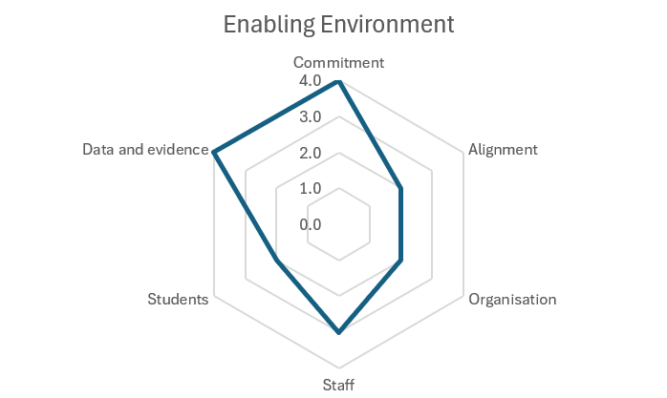

Using a whole provider approach to inform and shape your widening access and student success strategy (including your APP).
Tools 4-6 support the development, implementation and evaluation of a whole provider approach. They were initially designed to support English HEPs in preparing their APPs, but they also have wider value for HEPs seeking to develop a whole provider approach to widening access and student success.

Tool 4: WPA template (for writing the WPA section of the APP)
This tool has been designed to help summarise your WPA to widening access and student success, either in your APP, or more generally. The tool can be downloaded here. This can provide a useful starting point to initiate conversations within a HEP about what needs to change to enable it to become an equitable institution. Here the suggested headings are reproduced as a suggested structure and to provide some boundaries.

1. Our institutional journey
- Reflections on institutional journey in relation to widening access and student success, for example in relation to the widening access and student success maturity model.
- Summary of achievements to date and future priorities, e.g. for the forthcoming APP period.

2. Our institutional and senior leadership commitment
- State commitment to student diversity and success within strategic plan, institutional values, etc.
- Provide details of senior managers’ widening access and student success expertise and involvement in leading APP work.
- Include overview of APP governance structures which demonstrate engagement of staff across the institution, students from equity groups and senior leaders.
- Indicate how resources are made available to support widening access and student success work across the HEP.
- Indicate how the work is coordinated across the HEP.

3. Our WPA student experience: Working across the student lifecycle and experience for all students
- Statement about working across the student lifecycle and student experience for all students.
- Our commitment to working through the curriculum to reach as many students as possible, and using targeted interventions when specific groups are not benefiting from our inclusive approach.
- Information about cross-institutional and ‘business as usual’ interventions, practices and organisational issues that have been designed for or benefit equity groups.
- List of new interventions being implemented to address gaps in whole provider approach.

4. HEP structures that prioritise and facilitate widening access and student success
- Provide details of how your HEP is organised to support and enable widening access and student success.
- Describe the alignment of institutional policies and processes, paying attention to key policies including equality and diversity, recruitment and admissions and learning and teaching.

5. Staff and student engagement and contribution to widening access and student success
- Demonstrate how staff and students engage in this agenda and work together to create change and implement widening access and student success work.
- Explain how the capacities of staff (including academics, professional, support and managers) and students are developed to promote equality, diversity, inclusion, wellbeing and success, and to tackle discrimination.
- Describe how you communicate with students to encourage and enable them to engage with activities and services, and with staff to share information and practices, and promote co-ordination and consistency.

6. Our use of data and evidence
- State how data, evidence, evaluation and learning underpin and drive your widening access and student success work.

7. Our commitment to review, develop and evaluate our WPA
- “As part of the process of preparing our APP, we have reviewed our WPA, drawing on previous and current research, and practice from across the sector…”.
- “We have identified one/two/three areas for development of our WPA. These are:...”.
- “We commit to implement and evaluate changes, informed by our the theory of change, as set out below…”.

Tool 5: WPA impact evaluation theory of change template
This tool is a theory of change (ToC) template. Completing a ToC template may help you to plan how to evaluate the changes or improvements that you intend to make with regard to your WPA to widening access and student success. The tool can be downloaded here. This could be piloting or rolling out student experience interventions, monitoring the use and effectiveness of ‘BAU’ work for students from targeted groups, or making specific improvements to your enabling environment (see the list of examples of enabling environment interventions under tool 3 above). The template is informed by the TASO Theory of Change guidance. If you are not familiar with ToC methods, TASO is a good place to start.

Figure 7: Theory of Change template
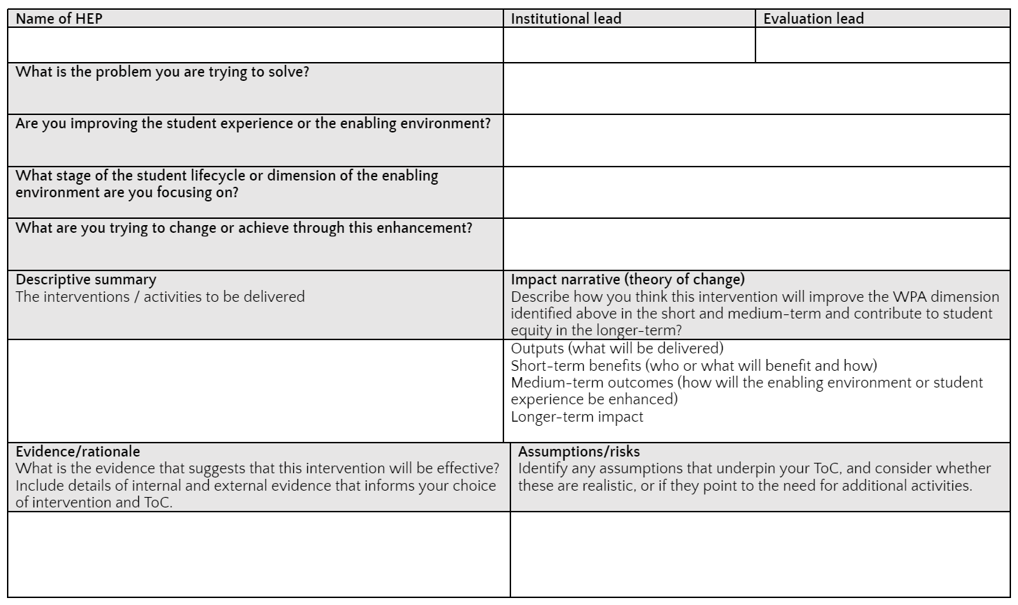
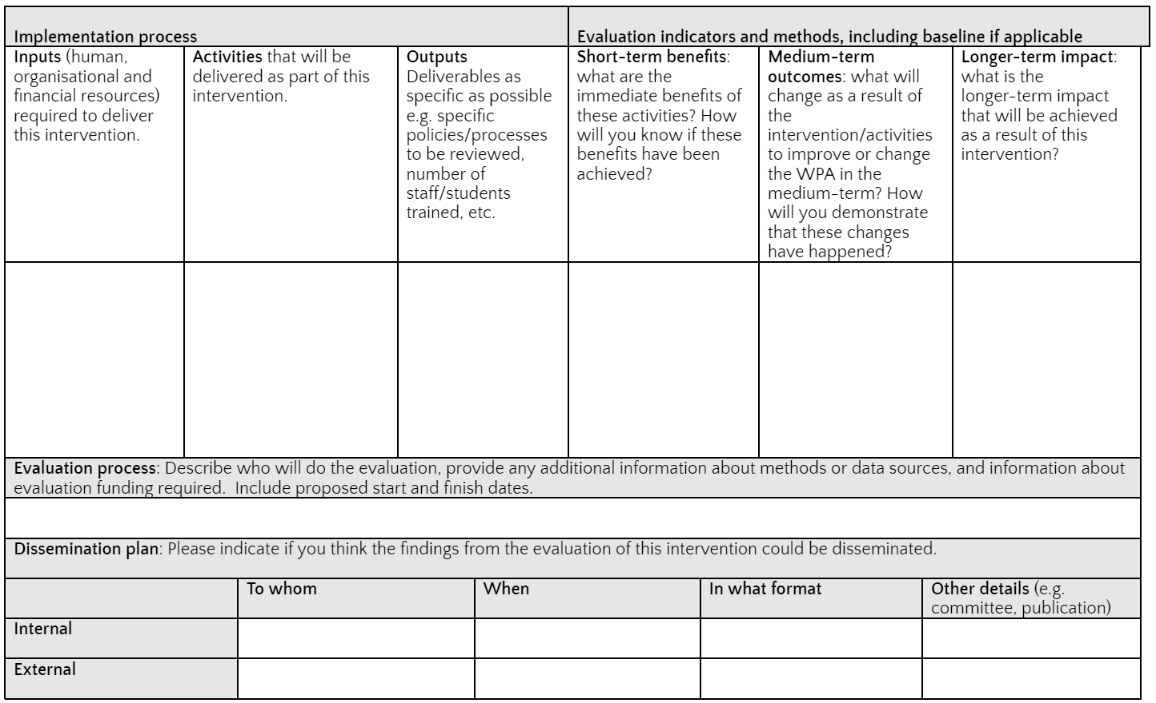

Tool 6: WPA evaluation planning tool (not available yet)
To assist the process of evaluating any changes you may make to the enabling environment, we have been working to identify indicators that relate to organisational change (rather than indicators that directly relate to students only). A full evaluation of your WPA would include an evaluation of widening access and student success interventions, as well as an evaluation of interventions to enhance the enabling environment.
The overall goal of a WPA to widening access and success is to improve the access of students from specific groups (e.g. to be more representative of the general population) and to close success gaps between groups (e.g. no gaps between student groups in relation to continuation, completion, attainment and progression to graduate employment or a higher level of study). Thus the ultimate indicators of an effective whole provider approach to widening access and student success are:
- Equitable access.
- No continuation gaps.
- No completion gaps.
- No awarding gaps.
- No progression (employment) gaps.
These are the longer-term impact goals of changes to the enabling environment as well for student experience widening access and student success interventions. These will usually be measured using institutional data.
The purpose of improving the enabling environment is to enable staff and students across the HEP to engage, deliver and benefit from the enhanced student experience, which will in turn result in equitable outcomes. This (usually) requires institutional change to avoid unintentionally disadvantaging some students – either directly (e.g. through timetabling) or indirectly by hampering the implementation of student experience changes that would be of benefit to them (see figure 4).

Longer-term goals for institutional change to enable a WPA to widening access and student success
The dimensions of the enabling environment tool are the longer-term goals for institutional change:
- Institutional and senior leadership commitment to widening access and student success is explicit, clearly communicated and demonstrated.
- HEP policies and process align with and enable widening access and student success.
- Communication and organisational arrangements facilitate widening access and student success.
- Staff have awareness, commitment and skills and engage and collaborate to implement widening access and student success activities, tackle inequality and discrimination and achieve institutional goals.
- Students have awareness, commitment, skills and opportunities to contribute to and benefit from widening access and student success activities and to tackle inequality and discrimination.
- Data, evidence, evaluation and learning both underpin and drive widening access and student success work.
These goals can be turned into indicators by drawing on the ‘indicators’ listed under each dimension (tab) on the Enabling Environment tool. These are summarised in Table 1 in appendix 1.

Short-term indicators for institutional change
These frequently relate to staff and students having the ability to act, as these groups constitute the HEP. This might include:
- Increased awareness of the issues.
- Wider and more diverse groups of staff/students involved widening access and student success work
- Greater knowledge and understanding about the risks (causes) of inequality or about changes required.
- Improved skills to address inequalities or implement change.
- Identification of (more) actual or potential inequalities.
- Increased responsibility/motivation to address inequalities.
- Increased confidence and empowerment to address inequalities.
- Necessary capacity (including time, skills, permission) to undertake change.
- Feel supported to take action, including to try things that do not work.
- Able to use data and evidence to inform work to address inequalities.
- Identified inequalities or causes to be addressed.
- Identified evidence-informed intervention or actions to take.
- (More) changes to practices, policies, processes etc have been planned.

Medium-term outcome indicators for institutional change
Medium-term indicators frequently relate to subsequent actions being implemented or changes occurring, beyond the initial intervention. For example:
- All or most changes have been made to practices, policies or processes.
- More staff/students involved in changing practices, policies or processes.
- More students from target groups able to engage/benefit from activities or services.
- Positive feedback from students or other stakeholders on the changes made.
- Student/staff feedback on changes is positive.
- Colleagues take (more) ownership and feel (more) responsible for implementing change.
- Colleagues continue to reflect on equity and identify challenges and areas for improvement.
- More evidence-informed decision-making.
- Increased knowledge, confidence and skills to address problems as they arise.
- New or greater connections made to other areas of work.
- Evaluation and learning are shared between parts of the HEP.
- Additional areas for change or improvement have been identified.

Worked example
This emergent framework can be developed by applying it to specific examples. In the section about Tool 3, some examples from wave 1 APPs are listed, these can be used to help develop and exemplify an evaluation framework for the institutional change. One such example is presented below. We will be collecting further examples and use these to develop the WPA evaluation planning tool.
Enabling environment intervention | Improve APP Governance structures
What is the problem you are trying to solve? | Each department has its own interventions to address the widening access and student success. There are weak structures to share the learning from the evaluations to improve the experience and outcomes from students across the HEP. There is a lack of staff and senior management involvement, meaning that the interventions do not operate across the HEP.
What stage(s) of the student lifecycle or dimension(s) of the enabling environment are you focusing on? | - Governance  - Co-ordination  - Staff engagement  - Student engagement  - Use of data and evidence
What are you trying to change or achieve through this enhancement? | Introducing governance structures that engage staff from across the institution, facilitate student involvement and which actively involve senior managers. The new structures will provide a forum for sharing and acting on data and evaluation evidence, and to make decisions and resources available to roll intervention out across the HEP, to improve the student experience and reduce gaps across the HEP.
Descriptive summary  The interventions / activities to be delivered (outputs) | APP Steering Board, meets quarterly, chaired by senior manager, involves key staff from across the HEP and student representatives; reports to Executive Team. Provides strategic oversight, including investment decisions, and roll out, continuation or withdrawal of interventions.  APP Operational Group, meets monthly, chaired by Head of APP, involves staff and student partners involved in delivering and evaluating interventions. Supports the implementation and evaluation of interventions and shares learning and practice across the HEP.
Indicators of success | Short-term benefits (who or what will benefit and how)  - Senior managers will take greater responsibility for the APP work.  - Staff from across the HEP will have opportunities to share their work with colleagues across the HEP.  - Student partners and representatives will be involved in the APP work.  - Managers, staff and students will have more knowledge and understanding of the issues and increased confidence to take action.  - Learning from the evaluations will be shared and there will be a route to action through recommendations to the APP Steering Board.  Medium-term outcomes (changes that will happen)  - Effective interventions are identified for roll out.  - Financial resources, staff time and change mechanisms (e.g. processes and accountability) are allocated/identified.  - Policy, process or organisational changes are identified and addressed.  - Process and impact evaluation of the roll out are overseen.  - Senior manager, staff and student partners and representatives feel more engaged in the APP work.  - APP work is more evidence-informed.  Longer-term impact on enabling environment  - Governance is more effective.  - Co-ordination is improved.  - Staff engagement is widened.  - Student engagement is widened.  - Use of data and evidence is increased.  Longer-term impact on student experience  - Improvements in access.  - Reduction in continuation, completion, awarding and progression gap.
Evidence/rationale | Institutionally we have evidence of effective interventions at the local level, and we believe that untested or ineffective/unproven interventions are being delivered.  The HEP lacks the infrastructure to review interventions and to plan roll out across all departments.  There is a mixed and inconsistent involvement of students in our APP work.
Assumptions/risks | There are some effective interventions to evaluate and roll out.  The new structure will be empowered to make strategic decisions about investment, roll out and additional enabling environment changes required

Our goal is to collect more worked examples and use this to develop an evaluation toolkit for WPA.

Putting it all together
The final section of the toolkit suggests how the various tools can be used together to improve your whole provider approach to widening access and student success. This is set out as a series of steps in Figure 8.

Figure 8: Suggested approach to developing a WPA to widening access and student success
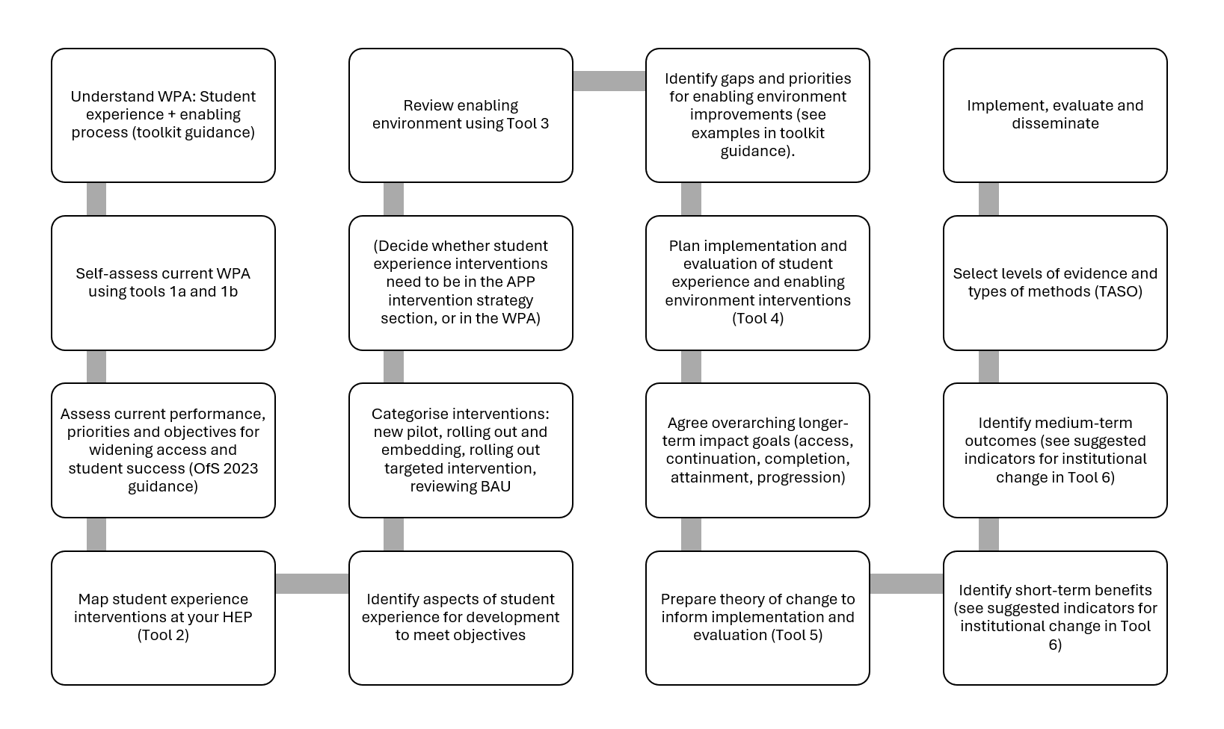

Conclusions
The concept and practice of whole provider approach is underdeveloped in the context of higher education. This toolkit has drawn on research and the experiences of practitioners to suggest some practical ways in which a whole provider approach can be understood and developed to promote student equity. There is still a great deal to do, and we hope that you will share your experiences with us so that we can continue to learn, develop and share ideas about a whole provider approach.

Appendix 1: Longer-term institutional change goals and potential indicators

Table 1: Longer-term institutional change goals and potential indicators (from the Enabling Environment Tool)
Longer-term institutional change goal | Potential Indicators
Institutional and senior leadership commitment to widening access and student success is explicit, clearly communicated and demonstrated. | The HEP's commitment to widening access and student success is explicit in our strategic plan, mission statement and other strategic documents.
 | Senior managers have knowledge and expertise about widening access and student success and are actively involved in leading our work in this area.
 | Our widening access and student success governance structures enable the engagement of staff from across the institution, students from equity groups and senior managers.
 | Widening access and student success work is co-ordinated across the HEP to ensure a strategic approach.
 | Adequate financial resources and staff time are made available to support widening access and students success work across the student lifecycle and the whole student experience.
HEP policies and process align with and enable widening access and student success. | Equality, diversity and inclusion policies and processes inform, and are informed by and support our widening access and student success goals and activities.
 | Academic experiences policies and processes are informed by and support widening access and student success goals and activities.
 | The Teaching Excellence Framework informs, and is informed by and supports, our widening access and student success goals and activities. (UK)
 | Student recruitment and admissions policies and processes are informed by and support widening access and student success goals and activities.
 | Student support policies and processes, in relation to academic development, personal wellbeing, financial support and professional development, are informed by and support widening access and student success goals and activities.
 | Policies and processes to facilitate employability, entrepreneurship and progression to graduate employment and postgraduate study are informed by and support widening access and students success goals and activities.
 | Services and facilities such as libraries, catering and estates are designed to enable all students to access and participate equitably.
 | Staff recruitment and training policies and practices are informed by and support widening access and student success goals and practices.
Communication and organisational arrangements facilitate widening access and student success. | There are appropriate structures and processes for sharing information and co-ordinating widening access and student success interventions across the HEP.
 | Staff and students have opportunities for interaction, students know how to contact staff, and staff responses are timely.
 | The academic timetable is flexible or organised to facilitate students from targeted groups to participate fully in their learning.
 | The virtual learning environment and online learning are used to facilitate student engagement and personalise learning.
 | Assessment organisation does not unintentionally disadvantage some groups (e.g. not overly bunched, flexible timings, online submission, compassionate extenuating circumstances).
 | Support and guidance including personal tutoring, academic development and wellbeing services are offered flexibly to accommodate complex lives.
 | Co-curricular and extra-curricular activities are offered when students are on campus, or in flexible ways.
 | Learning analytics is used to target communication with students.
 | Communication with students about academic matters is clear, jargon-free, relevant and timely.
 | Communication with students about support (academic, wellbeing, financial, etc) is clear, targeted and encourages engagement.
 | Communication with students about co-curricular, extra-curricular and social activities is inclusive and encouraging.
 | Communication with students uses appropriate media, language and images to reach and engage all students.
 | The HEP encourages and enables external collaboration and partnerships to support widening access and student success.
Staff engage and collaborate to implement widening access and student success activities, tackle inequality and discrimination. | The majority of staff across the HEP are aware of our institutional commitment to widening access and student success.
 | The majority of staff across the HEP are committed to our principles of widening access and student success.
 | The majority of staff across the HEP contribute to widening access and student success activities to achieve our goals.
 | Managers at all levels understand and value WP, diversity and success and encourage engagement and participation.
 | Staff recruitment includes assessment of their willingness to be developed to promote WP, EDI, student success and to tackle discrimination.
 | Staff induction/training develops role appropriate awareness and skills to enable all staff members to contribute fully to this work.
 | Continuing professional development and opportunities for reflection, scholarship and action research ensure staff continue to develop, contribute and make an impact on widening access and student success.
 | People from across the HEP meet together to discuss widening access, equality, diversity, inclusion and success, to share and develop their practice.
 | Staff from across the HEP feel able to initiate and implement WP interventions and practices.
 | Academic and professional staff work in partnership to bring about change to improve widening access and student success outcomes.
 | Staff are trained to enable them work in partnership with students to co-create an inclusive and equitable student experience. Staff are trained to enable them work in partnership with students to co-create an inclusive and equitable student experience.
 | The contribution of staff to widening access and student success is recognised and rewarded, e.g. through promotion criteria.
Students are able to contribute to and benefit from widening access and student success activities. | Our commitment to and respect for widening access, equality, diversity, inclusion and student success is shared by students across the HEP.
 | All students are trained and developed to promote equality, diversity and inclusion, and to notice and take appropriate action when discrimination occurs.
 | Students are trained/coached to enable them to engage in their learning experience and the wider student experience.
 | Students are trained to enable them work in partnership to co-create an inclusive and equitable student experience.
 | Students from across the HEP feel able to provide feedback, contribute and initiate change to widen access and improve student success.
 | There are opportunities for students to collaborate with staff to implement institutional change to widen access and improve student success.
 | There are opportunities for internal and external collaboration with networks and groups to develop capacity and provide support.
 | The contribution of students is recognised and rewarded, e.g. through accreditation, certification or payment.
Data, evidence, evaluation and learning underpin and drive widening access and student success work. | Institutional data, including intersectional analysis, research, evaluation and secondary evidence is widely and routinely used to improve widening access and student success.
 | Student attendance, engagement and success data is actively used to improve student outcomes.
 | HEP data systems are integrated and effective, providing real-time information.
 | Up to date widening access and student success data and evidence inform strategic decisions at the highest level and day-to-day decision-making at the local level.
 | Key performance indicators are used to help improve our widening access and success work at different levels across the HEP.
 | Systems are in place to evaluate our widening access and student success work.
 | Sufficient staff are allocated to support the use of data and evidence to widen access and improve student success.
 | Mechanisms are in place to learn from our evaluations and other relevant institutional and sector research and evaluation.
 | We disseminate our evaluation findings externally.

References
Felten, P., Gardner, J., Schroeder, C., Lambert, L. and Barefoot, B. (2016). The Undergraduate Experience. Focusing institutions on what matters most. San Francisco, CA: Jossey-Bass
Jones, R., & Thomas, L. (2005). The 2003 UK Government Higher Education White Paper: A critical assessment of its implications for the access and widening participation agenda. Journal of Education Policy, 20(5), 615-630.
Kift, S. (2015). A decade of Transition Pedagogy: A quantum leap in conceptualising the first year experience. HERDSA Review of Higher Education, Vol 2, pp 51-86.
Kift, S. (2023). Transition Pedagogy for 21st Century Student Success. In Baik, C. & Kahu, E. (2022). Research Handbook on the Student Experience in Higher Education. Edward Elgar Publishing https://doi.org/10.4337/9781802204193
Kift, S. (2024). “The quest for the holy grail of student engagement: Curriculum as the engagement integrator”, in Stone, C. & O’Shea, S. (2024). Research Handbook of Student Engagement in Higher Education. Edward Elgar Publishing.
Kuh, G. D., Kinzie, J., Schuh, J. H., & Whitt, E. J. (2010). Student Success in College: Creating Conditions That Matter. San Francisco, CA: Jossey-Bass.
Moore, J., Sanders, J., & Higham, L. (2013). Literature review of research into widening participation to higher education. Report to HEFCE and OFFA. AimHigher Research & Consultancy Network.
Office for Students (OfS) (2023a). Regulatory Notice 1: Access and participation plan guidance. OfS 2023.14. 29 March 2023. Office for Students. https://www.officeforstudents.org.uk/publications/regulatory-notice-1-access-and-participation-plan-guidance/
Office for Students (OfS) (2023b). Regulatory Advice 6: How to prepare your access and participation plan – effective practice advice. OfS 2023.21. 18 May 2023. Office for Students. https://www.officeforstudents.org.uk/publications/regulatory-advice-6-how-to-prepare-your-access-and-participation-plan-effective-practice-advice/
Shah, M., Kift, S., & Thomas, L. (2021). Student retention and success in higher education. Student retention and success in higher education: Institutional change for the 21st century. Palgrave MacMillan.
Thomas, L. (2002). Student retention in higher education: the role of institutional habitus. Journal of education policy, 17(4), 423-442.
Thomas, L. (2012). Building student engagement and belonging in Higher Education at a time of change. Paul Hamlyn Foundation.
Thomas, L. (2017). Understanding a whole institution approach to widening participation. Office for Fair Access.
Thomas, L. (2018a). Leadership for institutional change to promote diversity and success, in Shah, M. and McKay, J. (eds) Achieving equity and academic excellence in higher education: Global perspectives in an era of widening participation? Palgrave Macmillan.
Thomas, L. (2018b). Access to success and social mobility involves everyone! A whole institution approach to widening participation, in Billingham, S. (ed) Access to success and social mobility through higher education: A Curate’s Egg? Emerald Books.
Thomas, L. (2020) ‘I am happy just doing the work…’ Commuter student engagement and success and lessons for other equity groups, Higher Education Quarterly, 74:3, 290-303
Thomas, L., Hill, M., O’ Mahony, J. & Yorke, M. (2017). Supporting student success: Strategies for institutional change. What works? Student retention and success programme. Final report. London: Paul Hamlyn Foundation.
Thomas, L., & Tight, M. (Eds.). (2011). Institutional transformation to engage a diverse student body. Emerald Group Publishing Limited.
Zepke, N., & Leach, L. (2005). Integration and adaptation: Approaches to the student retention and achievement puzzle. Active Learning in higher education, 6(1), 46-59.

To cite this toolkit:
Thomas, L. (2024) A whole provider approach to widening access and student success in higher education: Toolkit and guidance. York: Centre for Research on Education and Social Justice, University of York

To provide feedback, share examples or for more information please contact:
liz.thomas@york.ac.uk

The generation of a radar chart is built into the enabling tools, and it is also available as a function within Excel.

